assignment #03

Course: CHE 301: Chemical Engineering Thermodynamics
Term: Fall 2025
Professor: Dr. Michael Caracotsios
Office: EIB 244

Cell Phone: (630) 696-0934
E-mail: mcaracot@uic.edu

Names: ___________________________________________
Due Date: Sunday, September 28th on or before 11:55 PM

INSTRUCTIONS FOR ASSIGNMENT DELIVERY

- Answer all questions on the Blackboard by the due date and time.
- Late Answers will not be accepted without prior approval.

Problem A: Supercritical steam generated in the steam generator (shown in the sketch below) at pressure and temperature is expanded into a series of two condensing steam turbines (CSTs) to a final pressure of as shown in the process diagram below. To improve the efficiency of the cycle, part of the exhaust of the High Pressure (HP) Turbine at is reheated to and sent to the Low Pressure (LP) Turbine for further expansion, and part is throttled (isenthalpically) down to a pressure of and mixed with the discharge of the Condensate Pump of the Condenser effluent in the Open Feed Water Heater (OFWH) tank in order to preheat the boiler feed water. The Open Feed Water Heater also serves as the Deaerator by removing oxygen and other dissolved gases from the feed water. Total steam losses from the Deaerator amount to about 1% of the steam input from the HP turbine to the OFWH. This power cycle is known as the Regenerative Rankine Cycle with Open Feed Water Heater and it is shown in the diagram below:

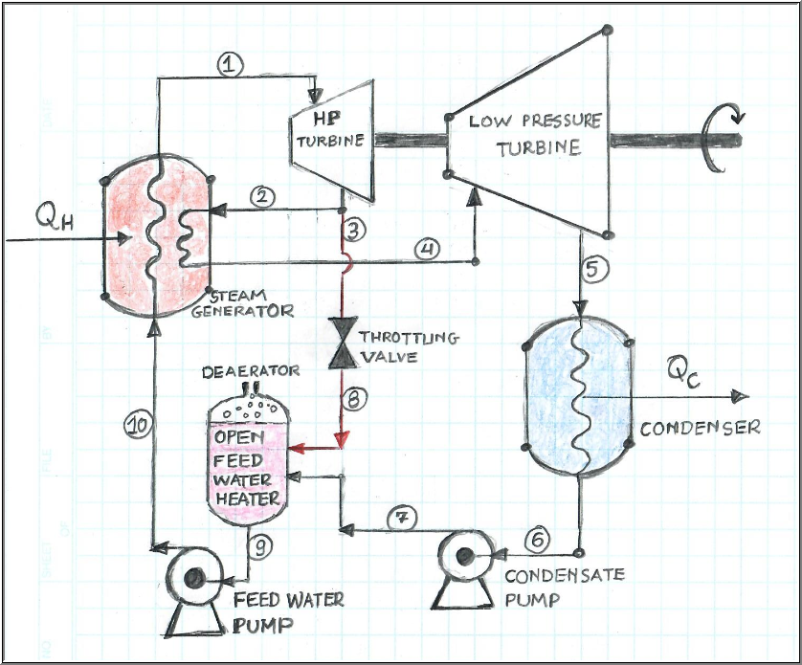

The following operating data are available for this power plant:

- Total power generated from the two turbines: 750 MW
- HP (High Pressure) turbine discharge pressure: 40 bar
- Throttling valve operation: Isenthalpic
- Temperature of Stream S6 subcooled liquid by 2 ºC
- Thermodynamic State of Stream S9: Saturated Liquid
- HP and LP Turbine efficiency: 80%
- Condensate pump efficiency: 75%
- Feed Water pump efficiency: 75%
- Fuel used: Bituminous Coal with heating value: 22 MJ/kg
- Carbon content of Bituminous Coal: 90 % wt.
- Boiler efficiency: 80%

Tasks: Answer all questions on the UIC Blackboard

